**FPT ACADEMY INTERNATIONAL**



## FPT – APTECH COMPUTER EDUCATION

**USER GUIDE**

**QUICK CALLIGRAPHY**

|  |  |  |  |  |  |
| --- | --- | --- | --- | --- | --- |
| **Center Name** | | FPT – Aptech – HCM2  Address: 590 Cach Mang Thang Tam, District 3, Ho Chi Minh City | | | |
| **Instructor** |  | | Ms. Le Mong Thuy | |  | |
| **Class** |  | | T1.2303.M0 | |  | |
| **Group** |  | | 1 | |  | |
| **Group members** | | **Name** | | **Student ID** | |
|  |  | | Vu Minh Tuan | | Student1459120 | |
|  |  | | Bui Thi Nhung | | Student1459130 | |
|  |  | | Chu Quoc Huy | | Student1459125 | |
| **Duration** | Start date | | 19th June 2023 | |  | |
| End date | | 26th July 2023 | |  | |

# TABLE OF CONTENT

FPT – APTECH COMPUTER EDUCATION 1

TABLE OF CONTENT 2

SYSTEM REQUIREMENT 3

WEBSITE INSTALLATION 4

OVER VIEW 6

1. HEADER 7

2. FOOTER 7

3. HOME 8

4. CALLIGRAPHY 9

5. CATEGORIES (ARABIC, EAST ASIAN, GREEK, INDIC, WESTERN) 10

6. LEARN BASIC 10

7. LEARN INTERMEDIATE 11

8. LEARN ADVANCED 12

9. GALLERY 12

10. CONTACT 14

11. FEEDBACK 18

# SYSTEM REQUIREMENT

|  |  |  |
| --- | --- | --- |
| **No** | **Software** | **Description** |
| 1 | Operating system | Window 8 or higher |
| 2 | Hardware | Pentium 166 or better  64 Megabytes of RAM or better |
| 3 | Software | Notepad/ HTML editor/ CoffeeCup |
| 4 | Web browser | MS IE / Chrome / FireFox / Netscape /MS Edge |

# WEBSITE INSTALLATION

* This document was created to guide users to use the website – Quick Calligraphy effectively. It is advisable that users should read this material before starting to use this site in practice.
* To run Quick Calligraphy website, users can follow the following options:

1. **Direct access via our project github link:**

<https://moxxi123.github.io/T1.2303.M0-eProject-Group_1-QuickCalligraphy/>

1. **Download our project from github by following these steps:**

**Step 1:** Visit our group project github repository address at:

<https://github.com/Moxxi123/T1.2303.M0-eProject-Group_1-QuickCalligraphy>

**Step 2:** In the < > Code tab, click Download as ZIP (follow the instructions image bellow).

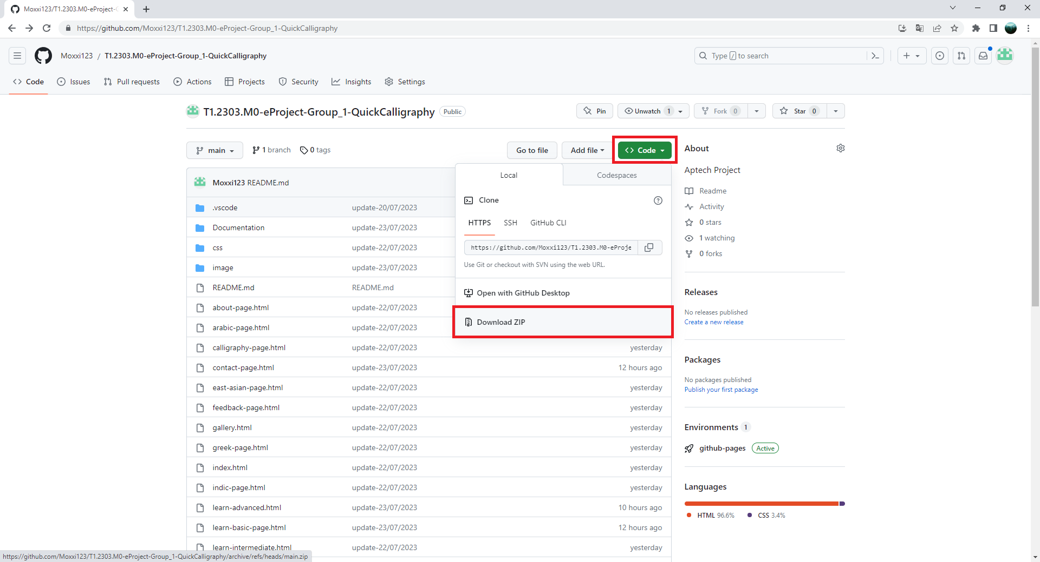

**Step 3:** Extract file rar: T1.2303.M0-eProject-Group_1-QuickCalligraphy-main.

**Step 4:** Open index.html file to start the website.

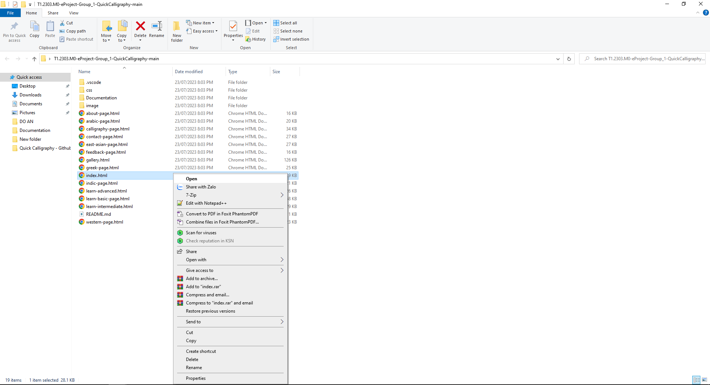

# OVER VIEW

There total 15 pages includes 8 main pages and 8 sub-pages in the Quick Calligraphy website.

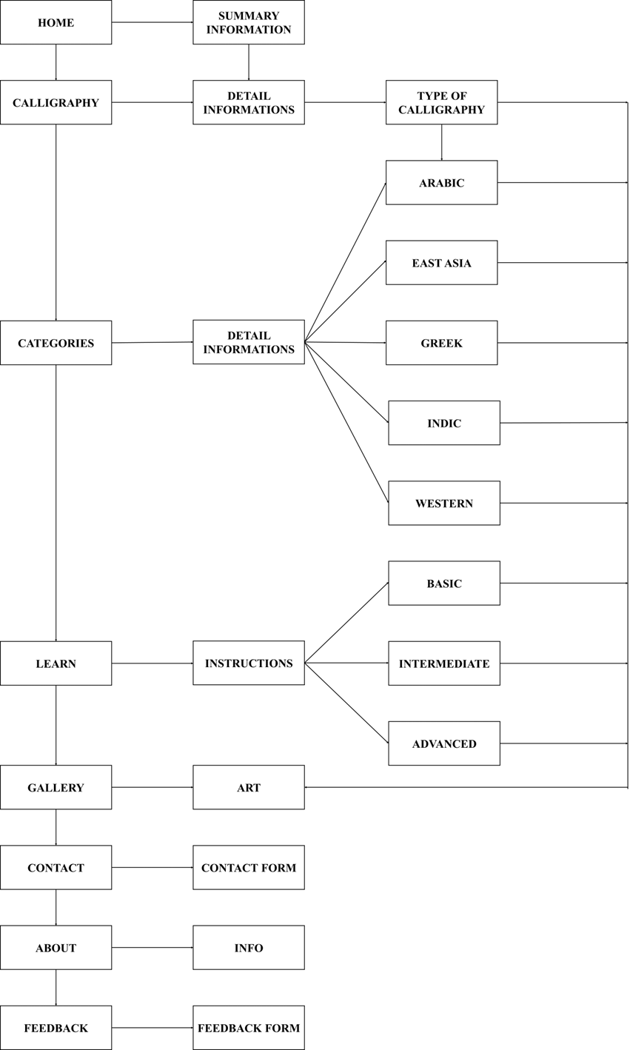

## HEADER

The header is on top of every page. It contains Website Logo, and Navigation Menu for all the webpage sections in the Quick Calligraphy website.

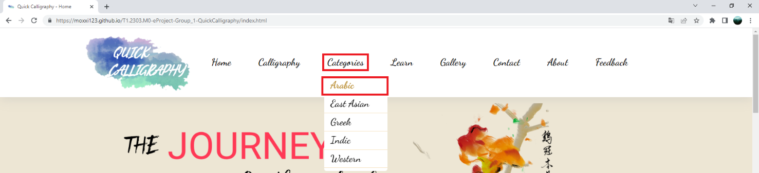

When the browser window is minimized, the menu in the header can be accessed by clicking on 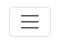icon. Then the thumbnail menu will be displayed as image bellow

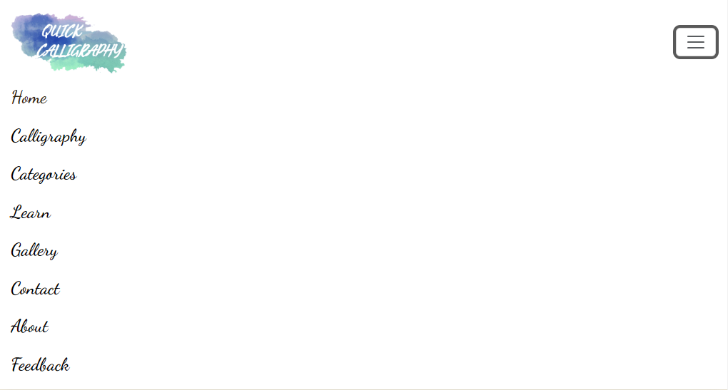

## FOOTER

The footer is at the bottom of every page. It contains links to About, Calligraphy, Gallery, Learn from Basic to Advanced, Contact, and Feedback. It also links to popular social networks such as Twitter, Facebook, and Google Mail.

The users can enter their mail in the “Your mail here” field of the footer section. The field will validate the data input. If it matches the abc@abc.com pattern, the field will let the user press the “Subscribe” button. But if the data does not match, the “Subscribe” button will be disabled and the error message will display.

**Case 1:** The data input matches the pattern:

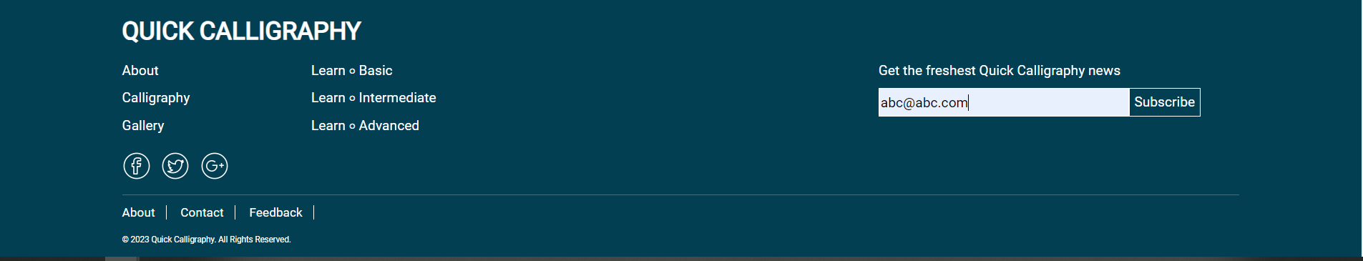

**Case 2:** The data input does not match the pattern:

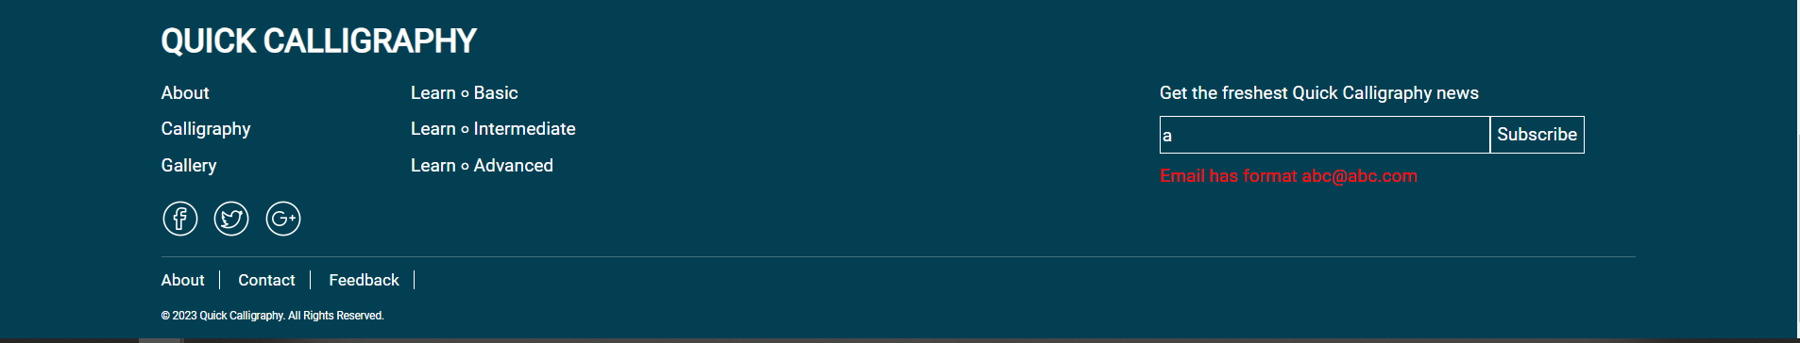

## HOME

1. **Image slider**

The images in the slider are auto-run cycles by default. Users can manually change the image by clicking on the navigation arrow on the left or right side of the slider. The image also changes when dragging the image to the left or right or clicking on the navigation dot at the bottom of the slider.

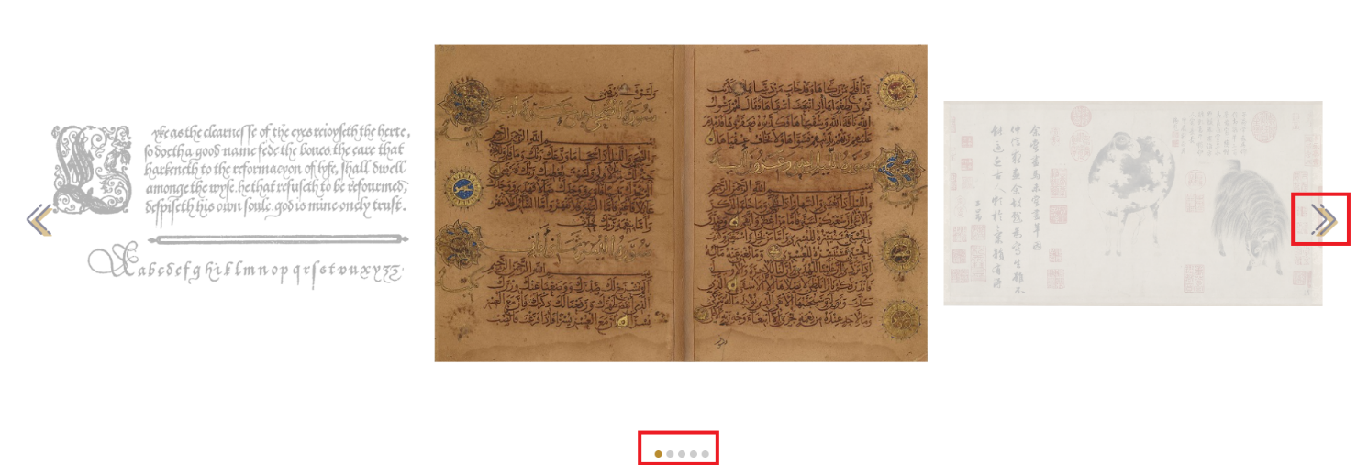

1. **Hyper link**

The hyperlink inside “Learn more” button in each content segment will lead to the respective pages. If the user is interested in any content, they can click this button to be redirected to the page of that content. For example, the “Learn more” button in Introduction and History will redirect to the Calligraphy page, while the “Learn more” button in Arabic, East Asian, Greek, Indic, and Western will redirect to the respective pages.

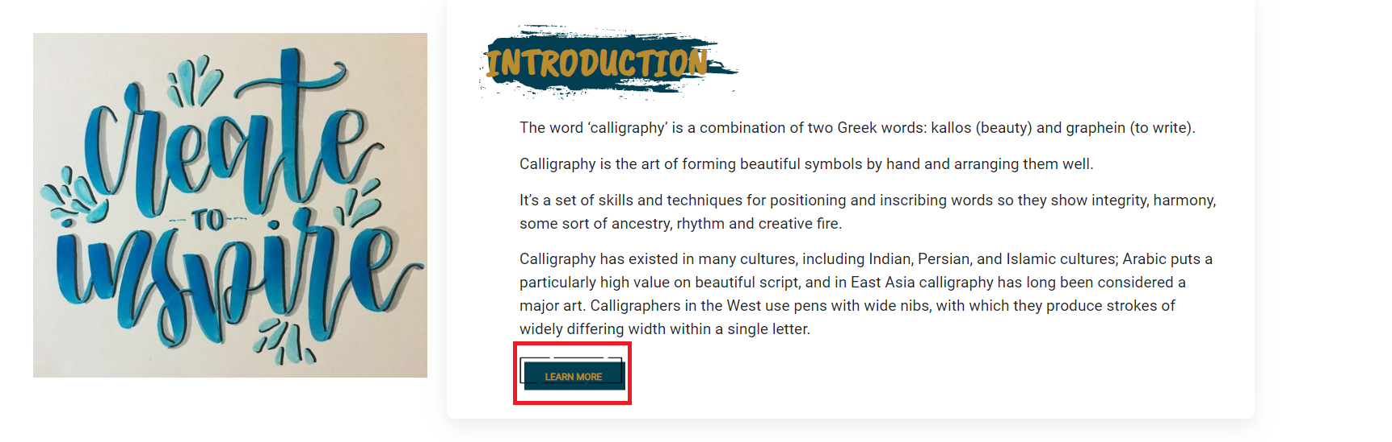

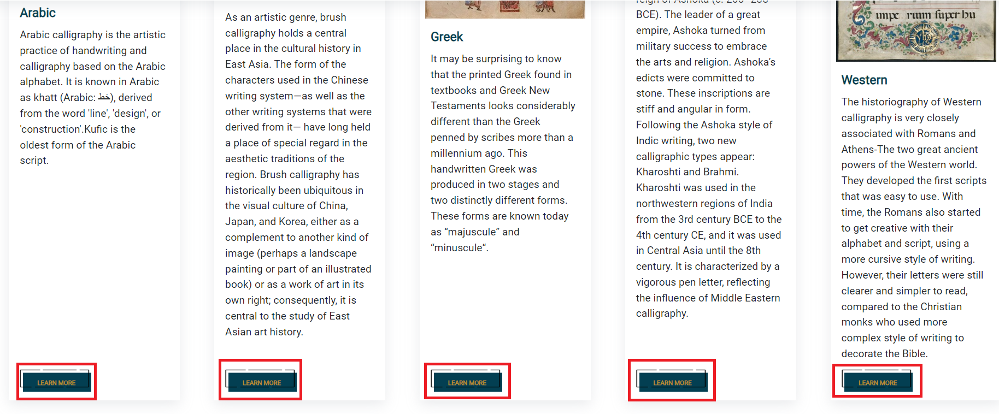

## CALLIGRAPHY

1. **Image hover**

In “Some motivational calligraphy art”, users can change the color of the pictures back to the origin by moving the mouse into them.

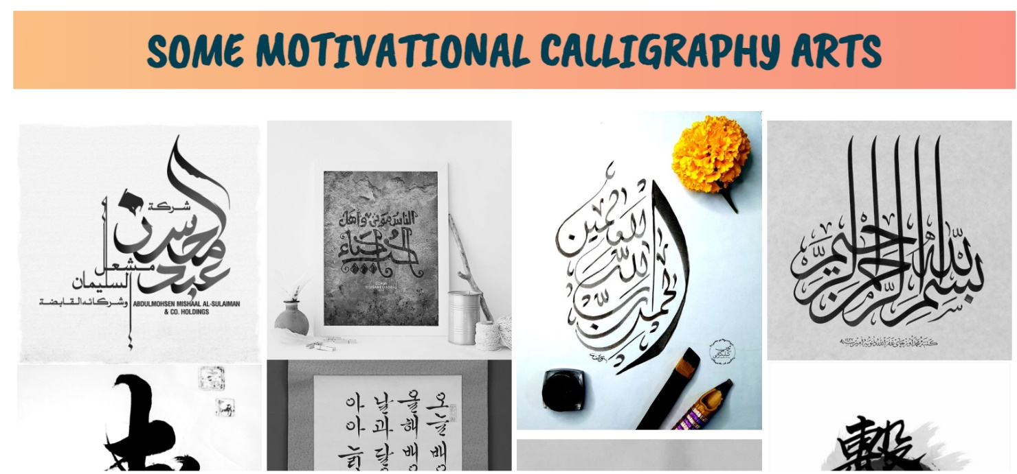

## CATEGORIES (ARABIC, EAST ASIAN, GREEK, INDIC, WESTERN)

1. **Image hover**

In “Exploring calligraphy”, users can learn about the content of each picture by moving the mouse to them.

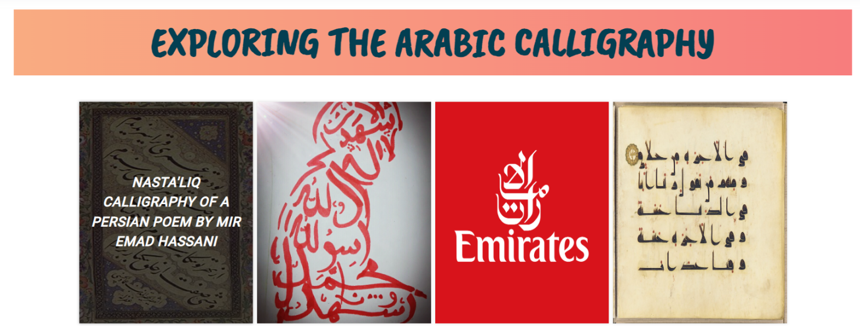

## LEARN BASIC

1. **Pop up content**

In “The basic calligraphy equipment”, users can read more information about each piece of equipment by clicking the “Read more” button.

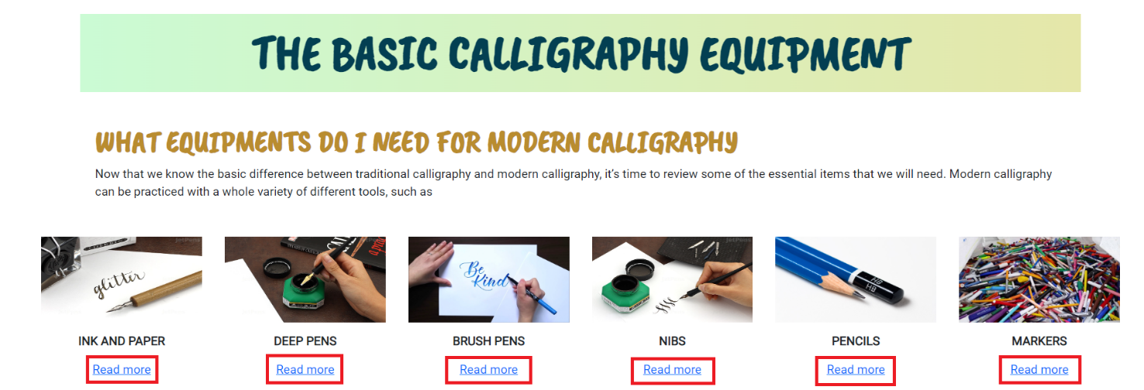

After reading the pop-up information, the users can escape the panel by clicking on the  button or clicking outside.

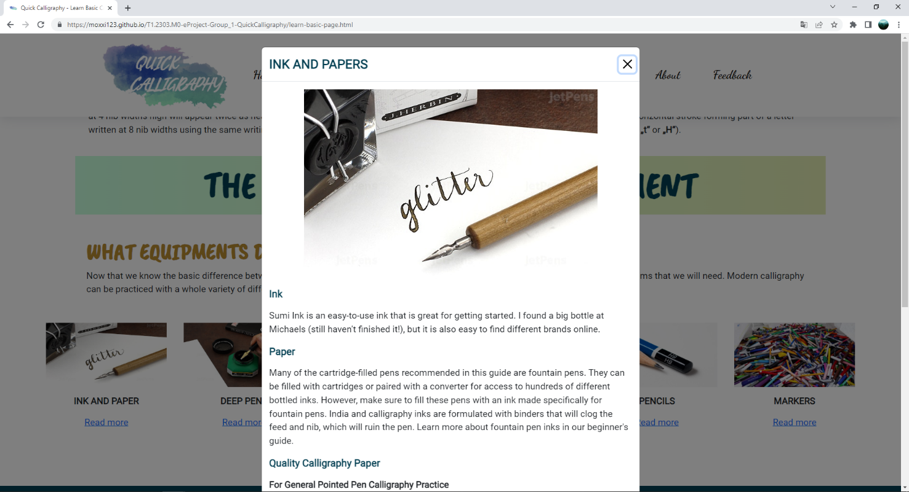

## LEARN INTERMEDIATE

1. **Image slider**

The images in the slider are auto-run cycles by default. Users can manually change the image by dragging the image to the left or right.

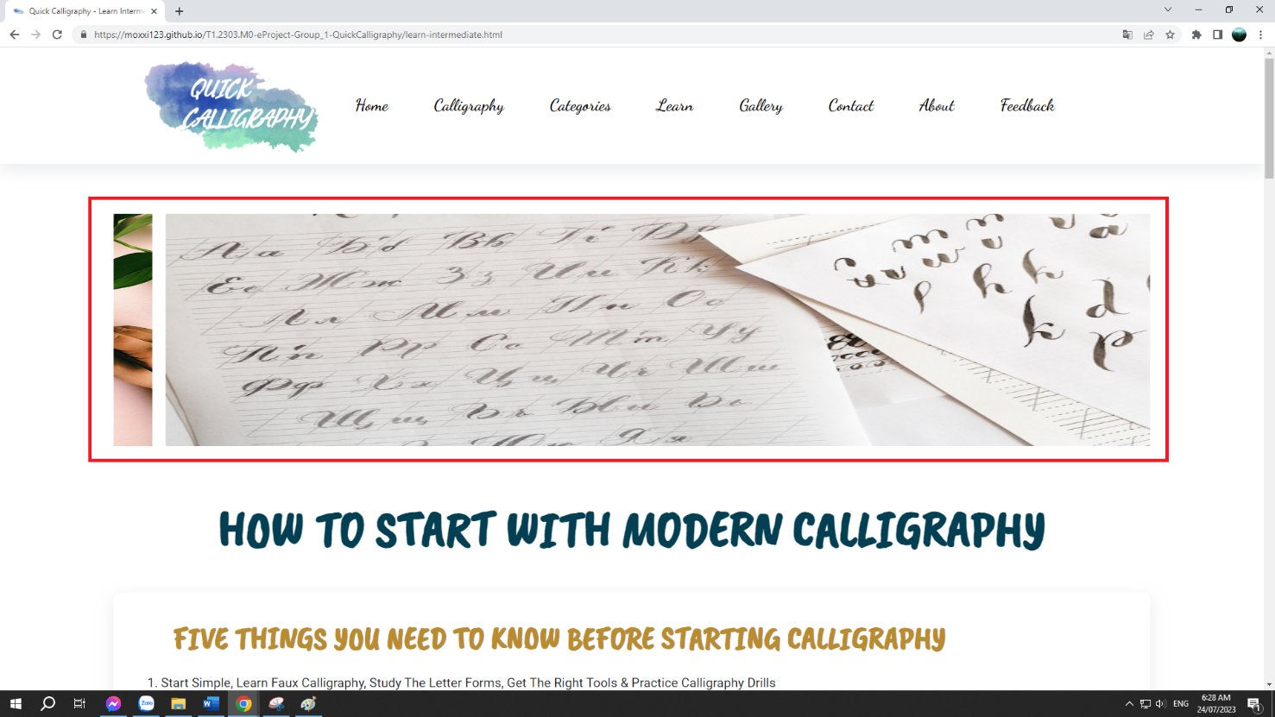

## LEARN ADVANCED

1. **Video**

The video inside each content segment can be played or paused like a normal YouTube clip. If users want to view those calligraphy instruction clips. They can click on  to start.

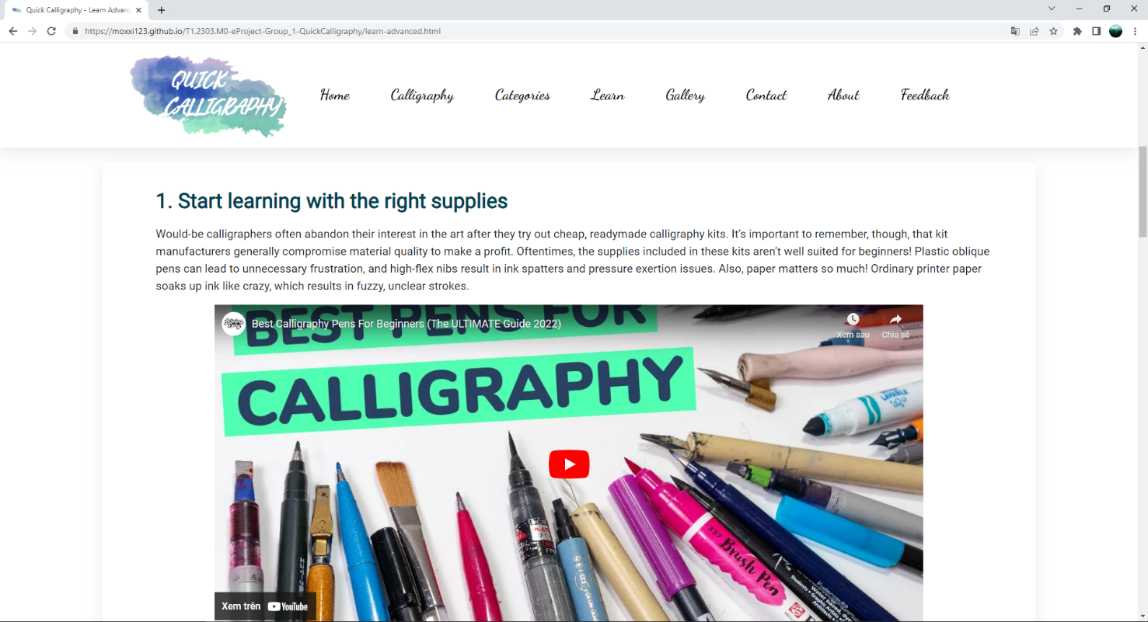

## GALLERY

1. **Search bar**

Users can search for image categories (Arabic, East Asian, Greek, Indic, Western) by typing directly in the search bar to make the filter function run immediately without the need for enter button.



1. **Sort sidebar**

Similar to the search bar, the sort sidebar can also be used to filter images by the previous category. The “All category” option is set by default when loading the Gallery page.

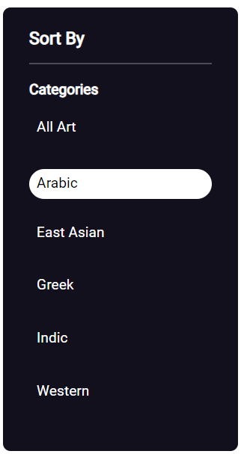

1. **View count when clicking on the image**

The images in the gallery have the function for storing and re-displaying the number of views when clicking on them.

The number of views was shown next to the icon  at the bottom left of the image.

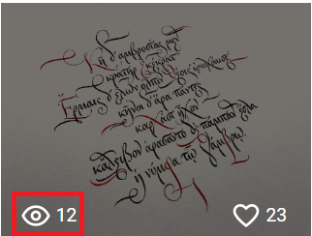

1. **Like count when clicking on the “Love” button**

Similar to the image, the “Love” button also has the function for storing and re-displaying the number of clicks when clicking on it.

The number of clicks was shown next to the icon 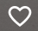 at the bottom right of the image.

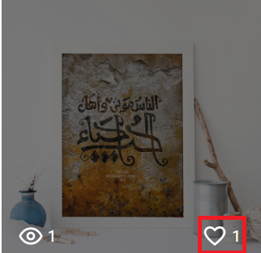

1. **Pop up image slider**

When users click on the image in the gallery, an image slider will pop up with a similar one. They can also manually change the image by clicking the navigation arrow on the left or right side of the slider. In case exiting the pop-up panel, they can use the button  at the top right of the image.

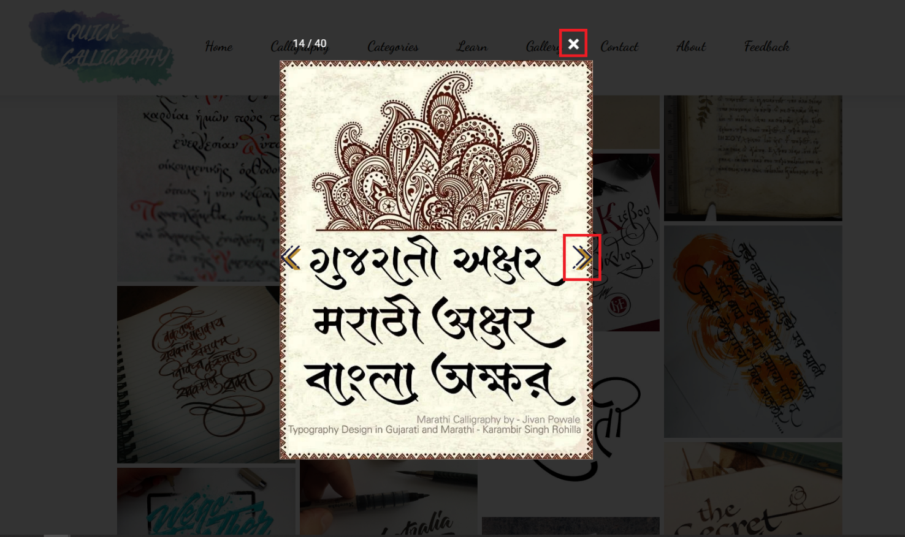

## CONTACT

1. **Mail us button**

This button will allow users to quickly and easily send an email to the Quick Calligraphy address (aptech.fpt@fe.edu.vn). But it will behave differently depending on the user's browser settings. The users can change how mailto: links behave in Chrome by visiting chrome://settings/handlers, or Chrome Settings->Content Settings->Manage Handlers...



1. **Name input**

This is a required field to fill in. However, it will not give a requirement error when the user has not edited it.

The users can enter their names in the “Name*” field of the contact form section. The field will validate the data input. If it has a format of at least 1 character except for space, the field will turn green and let the user pass. But if the data does not match the condition, the field will turn red and the error message will display.

**Case 1:** The data input matches the pattern:

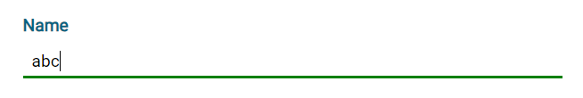

**Case 2:** The data input does not match the pattern:

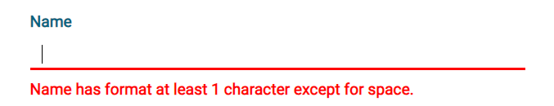

**Case 3:** The field is edited but does not have the data input:

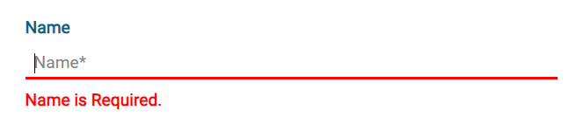

1. **Email input**

This is a required field to fill in. However, it will not give a requirement error when the user has not edited it.

The users can enter their mail in the “Email*” field of the contact form section. The field will validate the data input. If it matches the abc@abc.com pattern, the field will turn green and let the user pass. But if the data does not match the condition, the field will turn red and the error message will display.

**Case 1:** The data input matches the pattern:

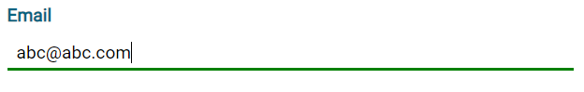

**Case 2:** The data input does not match the pattern:

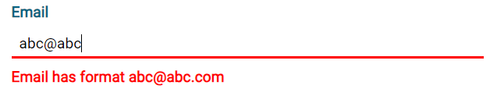

**Case 3:** The field is edited but does not have the data input:

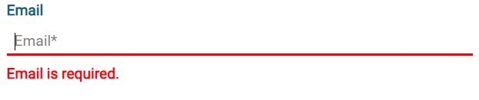

1. **Message input**

This is not required to fill in the field. The users can enter anything they want to ask the Quick Calligraphy.

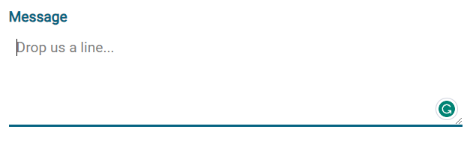

1. **Terms of service**

This is a required check box. By clicking accept users agree to Quick Calligraphy’s terms of service. Users can also read the full terms of service through a pop-up document by clicking on the “Terms of Service” text.

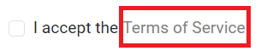

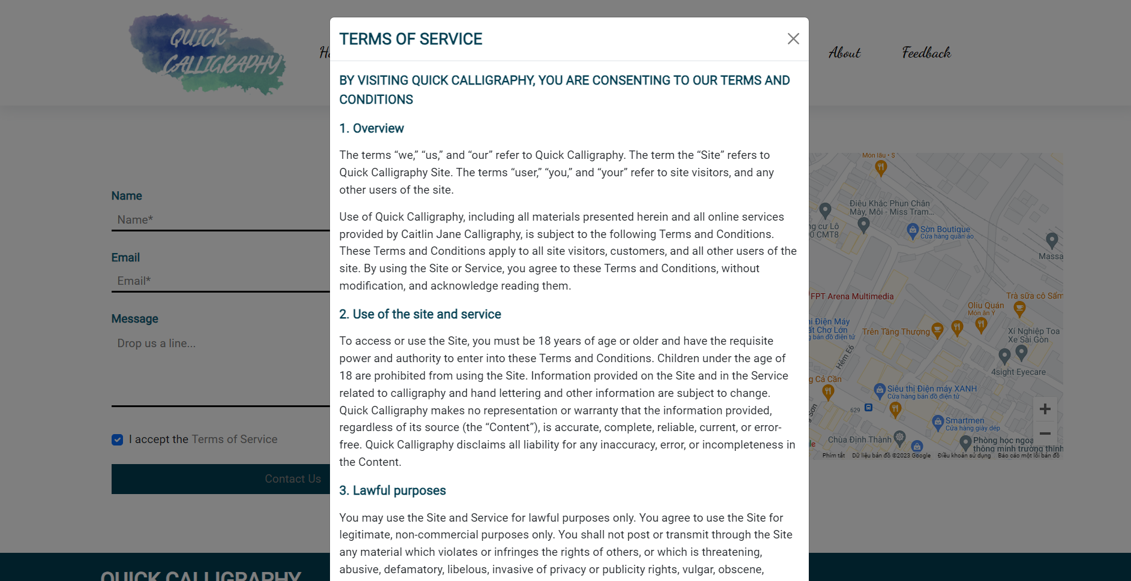

1. **Contact Us button**

This button will send users full name, email address, and question to the Quick Calligraphy website only if all input fields are error-free and the “I accept the Terms of Service” box is ticked.

**Case 1:** All input fields are error-free and the “I accept the Terms of Service” box is ticked:

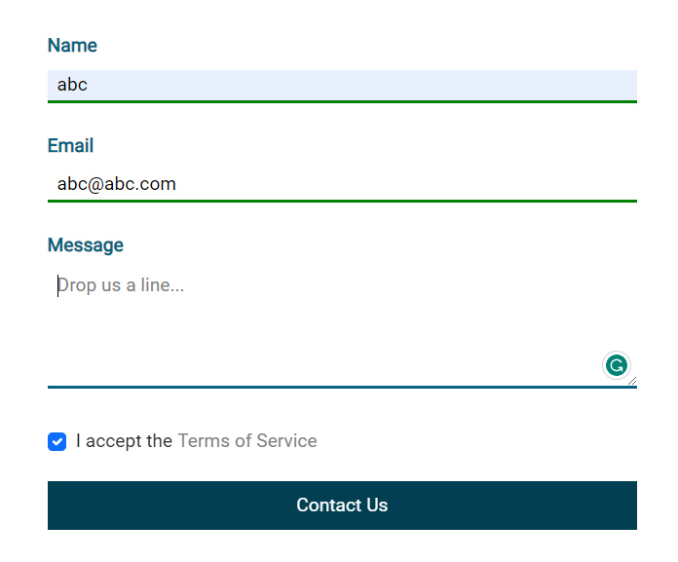

**Case 2:** One input field error or the “I accept the Terms of Service” box is not ticked:

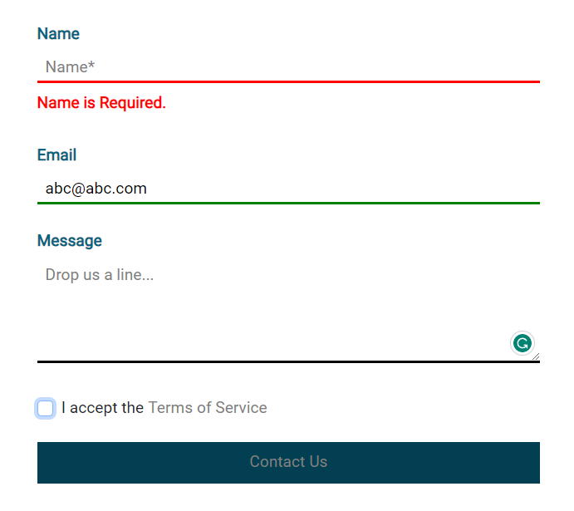

1. **Google map**

Users can use Google Maps to navigate to the address of the Quick Calligraphy. If you have trouble locating it, you can also use the “Get Direction” button to open a full-size window on Google Maps.

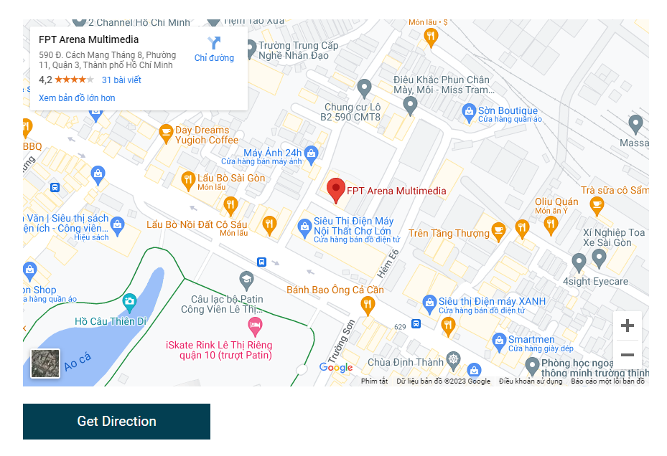

1. **FEEDBACK**
2. **Name input**

This is a required field to fill in. However, it will not give a requirement error when the user has not edited it.

The users can enter their names in the “Name*” field of the contact form section. The field will validate the data input. If it has a format of at least 1 character except for space, the field will turn green and let the user pass. But if the data does not match the condition, the field will turn red and the error message will display.

**Case 1:** The data input matches the pattern:



**Case 2:** The data input does not match the pattern:



**Case 3:** The field is edited but does not have the data input:



1. **Email input**

This is a required field to fill in. However, it will not give a requirement error when the user has not edited it.

The users can enter their mail in the “Email*” field of the contact form section. The field will validate the data input. If it matches the abc@abc.com pattern, the field will turn green and let the user pass. But if the data does not match the condition, the field will turn red and the error message will display.

**Case 1:** The data input matches the pattern:



**Case 2:** The data input does not match the pattern:



**Case 3:** The field is edited but does not have the data input:



1. **Rate scale**

This is not required field. Users can rate as many points as they like on a scale of 1 to 5 by dragging the slider left or right. By default, the score will be 5

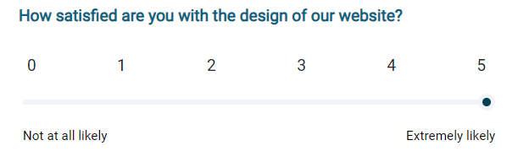

1. **Message input**

This is not required to fill in the field. The users can enter anything reason they want to when rating the Quick Calligraphy.

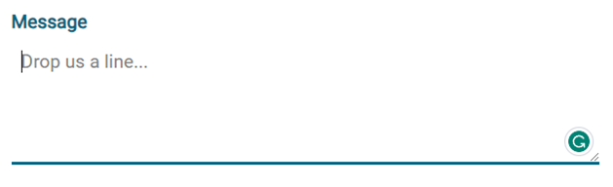

1. **Send Feedback button**

This button will send users full name, email address, and the reason why users give the rate point to the Quick Calligraphy website only if all input fields are error-free.

**Case 1:** All input fields are error-free:

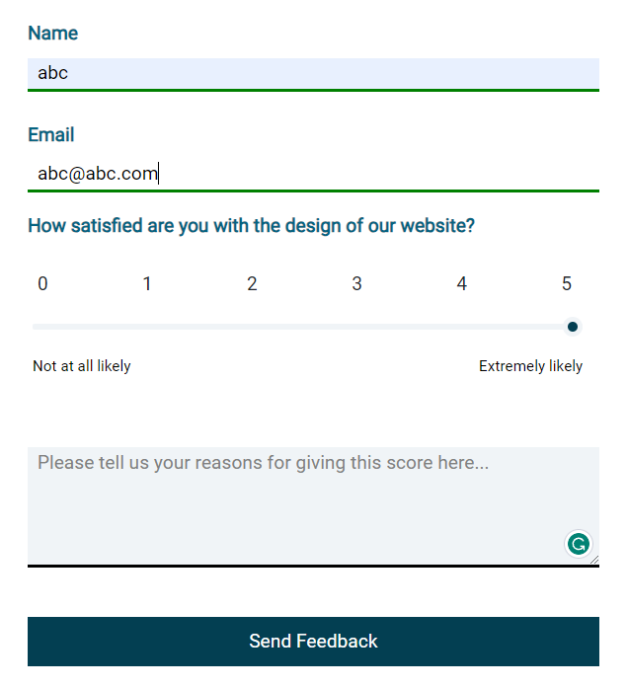

**Case 2:** One input field error:

